Epsom & Ewell
18
v
Farnham Town
Saturday, 2nd February 2019 – 3.00 p.m.
Good afternoon and welcome to the players, supporters and officials of Farnham Town who are visiting us for an extremely important League match for both teams.

It’s interesting to look back at last season and see how badly our two teams were faring as we unsuccessfully battled the drop from the Premier Division; both clubs falling well short of survival in the end. It’s also interesting to see how resilient clubs can be, with both of us now in a much more positive frame of mind to just twelve months previously.

Our visitors are having a very good season, while we remain in contention for three cups and still have an outside shot at pinching a promotion spot. When I originally wrote these notes, I felt that this was a “must win” match while Farnham might be happy with a draw. However, two defeats in the last week for our opponents have left them equally desperate for all three points today as we already have plenty of competition from Sheerwater, Frimley Green and Bedfont & Feltham. I think that this remains an extremely important match, in fact, arguably more so now.

We were last on show here two weeks ago when we started well against Bagshot before losing our way, only to then produce a stunning five goal burst in the final twenty minutes to win 7-1. We then visited Godalming Town last Saturday and came through with a 3-1 win. It was a fairly even match until the hour when we responded well to conceding and were well in charge by the end.

We head to the Orchard in just three days for an enticing League Division One Cup Quarter-Final to play a Bedfont & Feltham team that we were unlucky not to defeat just before Christmas. The winners of this tie will probably be favourites for the cup. We have no match on Saturday but host Godalming Town the following Tuesday in the League Cup with the winners knowing they would face a tough trip to Abbey Rangers in the Quarter-Final. In our third remaining cup we will now visit Imber Court for a match with the Met Police Academy under 23s on Wednesday 20th February.

Finally, please note that the League match against Sheerwater that was postponed on 22nd December is now to be played on Tuesday 19th March. Another big one!

Today’s match is kindly sponsored in memory of long serving supporter Chris Henry who left us far too early in 2004. He would be 60 now and it is worth noting that 50 years ago last weekend he saw his first ever match, a goalless draw with Marlow. I have no doubt whatsoever that he’d still be here now watching the Salts if he was still with us. Rest in peace Chris.

Enjoy the game!

Rich

You can follow us on social media. Just look on the inside cover of the programme for options

Cover photos by Gemma Jarman

- Reisse Griffin’s header draws us level at Cove on 5th January in a match we would win 2-1.
- A debut goal for Billy Carney as he heads our fourth goal of seven against Bagshot.
- Ben Chick also scored his first goals in that same match. Here is his second and our sixth.

Cherry Red Records Combined Counties League
Division One Table 2018/19
inc Tuesday 29th January 2019 | P | W | D | L | F | A | Pts | GD | H | A

Frimley Green | 24 | 16 | 5 | 3 | 48 | 27 | 53 | +21 | 3-0 | 23/2
Sheerwater | 24 | 16 | 4 | 4 | 63 | 32 | 52 | +31 | 2-3 | 19/3
Bedfont & Feltham | 22 | 15 | 5 | 2 | 74 | 25 | 50 | +49 | 4-4 | 13/4
Epsom & Ewell | 24 | 15 | 3 | 6 | 61 | 37 | 48 | +24 | X | X
Farnham Town | 21 | 13 | 4 | 4 | 46 | 19 | 43 | +27 | 2/2 | 1-4
Tooting Bec | 22 | 12 | 5 | 5 | 51 | 28 | 41 | +23 | 3-1 | 30/3
Ash United | 24 | 11 | 5 | 8 | 60 | 52 | 38 | +8 | 1-1 | 2-1
Dorking Wanderers Res | 26 | 11 | 4 | 11 | 55 | 56 | 37 | -1 | 3-0 | 3-5
Sandhurst Town | 21 | 11 | 3 | 7 | 33 | 35 | 36 | -2 | 20/4 | 2-0
British Airways | 23 | 9 | 4 | 10 | 49 | 55 | 31 | -6 | 16/2 | 2-3
Chessington & Hook Utd | 21 | 8 | 5 | 8 | 39 | 41 | 29 | -2 | 1-2 | 4-1
Bagshot | 26 | 7 | 4 | 15 | 33 | 77 | 25 | -44 | 7-1 | 3-0
Godalming Town | 22 | 6 | 3 | 13 | 32 | 53 | 21 | -21 | 3-2 | 3-1
FC Deportivo Galicia | 21 | 5 | 3 | 13 | 33 | 39 | 18 | -6 | 12/3 | 3-0
Eversley & California | 21 | 5 | 2 | 14 | 38 | 53 | 17 | -15 | 1-0 | 1-2
Cove | 22 | 4 | 2 | 16 | 28 | 50 | 14 | -22 | 3-2 | 2-1
Kensington Borough | 22 | 3 | 5 | 14 | 27 | 59 | 14 | -32 | 1-1 | 9/3
Fleet Spurs | 22 | 4 | 0 | 18 | 36 | 68 | 12 | -32 | 6/4 | 3-2

AC London (removed) | 15 | 9 | 2 | 4 | 36 | 25 | 29 | +11 | - | 6-0

Lucky Day? – 2nd February
Played 15 - Won 10 Drawn 2 Lost 3 - For 37 Against 23 - PPG 2.13 – Very Good
Our Club record against Farnham Town
Played 18 - Won 9 Drawn 4 Lost 5 - For 31 Against 29 - PPG 1.72 - Good
Our Largest wins and losses against Farnham Town
14th November 2017 - W 3-0 - Combined Counties League (H)
20th March 2012 - L 1-4 - Combined Counties League (H)
20th October 2018 - L 1-4 - Combined Counties League (A)
Farnham Town’s Last Visit
14th November 2017 - Won 3-0 - Combined Counties League

First Eleven Appearances 2018/19 - (max 33)
Name | Debut | 2018/19 |  |  |  | Career Totals
 |  | App | Sub | Tot | Goals | App | Sub | Tot | Goals
BENNETT Bobby | 12/08/2018 | 27 | 0 | 27 | 19 | 27 | 0 | 27 | 19
BETANCOURT Steve* | 18/08/2018 | 21 | 1 | 22 | 1 | 21 | 1 | 22 | 1
BORRETT Ricky* | 04/08/2018 | 9 | 0 | 9 | 0 | 9 | 0 | 9 | 0
CAMPBELL Kieran* | 29/09/2012 | 7 | 3 | 10 | 2 | 59 | 3 | 62 | 2
CAMPBELL Theo* | 28/08/2018 | 2 | 9 | 11 | 1 | 2 | 9 | 11 | 1
CARNEY Billy | 12/01/2019 | 2 | 1 | 3 | 2 | 2 | 1 | 3 | 2
CAULCRICK Joshua | 17/02/2018 | 0 | 4 | 4 | 0 | 0 | 5 | 5 | 0
CHICK Ben | 29/12/2018 | 2 | 3 | 5 | 2 | 2 | 3 | 5 | 2
CHIN Louis | 08/12/2018 | 6 | 0 | 6 | 0 | 6 | 0 | 6 | 0
CONNELLY Lloyd | 14/10/2017 | 32 | 0 | 32 | 4 | 62 | 4 | 66 | 6
DOBRAJ Endrit* | 18/11/2017 | 5 | 2 | 7 | 1 | 24 | 6 | 30 | 1
DYSON Ben* | 12/08/2017 | 0 | 1 | 1 | 0 | 28 | 14 | 42 | 2
ELGAR Luke | 04/08/2018 | 11 | 3 | 14 | 2 | 11 | 3 | 14 | 2
ELGAR Scott* | 12/08/2018 | 4 | 9 | 13 | 0 | 4 | 9 | 13 | 0
GAFFNEY Luke * | 16/08/2014 | 2 | 2 | 4 | 0 | 12 | 3 | 15 | 0
GAYLE Roy | 06/11/2018 | 3 | 3 | 6 | 0 | 3 | 3 | 6 | 0
GILL George* | 28/08/2018 | 2 | 0 | 2 | 0 | 2 | 0 | 2 | 0
GRIFFIN Reisse | 08/08/2015 | 18 | 0 | 18 | 3 | 122 | 13 | 135 | 11
GRIFFITHS Hakim | 08/12/2018 | 1 | 2 | 3 | 1 | 1 | 2 | 3 | 1
HEAGNEY Adam | 16/08/2016 | 32 | 0 | 32 | 1 | 99 | 13 | 112 | 3
HENDRY Rob | 08/08/2015 | 17 | 0 | 17 | 14 | 101 | 23 | 124 | 42
JEANNOEL Germaine | 02/12/2017 | 1 | 10 | 11 | 2 | 3 | 17 | 20 | 3
JONES David* | 31/08/2018 | 6 | 2 | 8 | 0 | 6 | 2 | 8 | 0
LOFTUS-CHEEK Joe* | 06/08/2017 | 0 | 1 | 1 | 0 | 14 | 8 | 22 | 6
MARTINEZ Olly | 29/09/2018 | 8 | 3 | 11 | 2 | 8 | 3 | 11 | 2
MCKAY Alex | 20/12/2008 | 1 | 0 | 1 | 0 | 163 | 39 | 202 | 13
MORGAN Sam | 11/09/2018 | 2 | 6 | 8 | 0 | 2 | 6 | 8 | 0
MURPHY Scott | 20/01/2007 | 28 | 0 | 28 | 3 | 75 | 2 | 77 | 7
MURPHY Todd | 27/11/2018 | 1 | 3 | 4 | 0 | 1 | 3 | 4 | 0
ROBERTS Liam | 12/08/2017 | 23 | 2 | 25 | 11 | 44 | 16 | 60 | 16
SMITH Taryn | 28/10/2017 | 6 | 6 | 12 | 5 | 14 | 10 | 24 | 5
SULLIVAN Ryan | 04/08/2018 | 21 | 1 | 22 | 0 | 21 | 1 | 22 | 0
SUTHERLAND Mitchel* | 04/08/2018 | 1 | 1 | 2 | 0 | 1 | 1 | 2 | 0
THOMPSON Elliott | 09/02/2016 | 22 | 4 | 26 | 1 | 32 | 13 | 45 | 2
WATTS Jamie | 03/11/2018 | 6 | 0 | 6 | 1 | 6 | 0 | 6 | 1
WHITE Sean* | 02/08/2014 | 9 | 4 | 13 | 4 | 29 | 25 | 54 | 9
WOODCOCK Josh* | 22/09/2018 | 1 | 0 | 1 | 0 | 1 | 0 | 1 | 0
WRIGHT Kieran* | 15/09/2018 | 3 | 3 | 6 | 0 | 3 | 3 | 6 | 0
YOUNG Conor | 07/03/2015 | 21 | 0 | 21 | 0 | 54 | 0 | 54 | 0
* - Player has left the club

Recent Results and Fixtures
Combined Counties League Cup Third Round – Wednesday 16th January 2019
FC Deportivo Galicia | 0-2 | Sutton Common Rovers
Guildford City | 0-2 | CB Hounslow United
Combined Counties League – Saturday 19th January 2019
Bedfont & Feltham | 7-1 | Fleet Spurs
Chessington & Hook United | 1-1 | Kensington Borough
Epsom & Ewell | 7-1 | Bagshot
Eversley & California | 2-2 | Cove
Farnham Town | 1-0 | Dorking Wanderers Reserves
FC Deportivo Galicia | 2-1 | Sandhurst Town
Sheerwater | 1-0 | Frimley Green
Combined Counties Division One League Cup QF – Tuesday 22nd January 2019
Tooting Bec | 2A1 | Frimley Green
Match abandoned at half time due to snow
Combined Counties League – Tuesday 22nd January 2019
Farnham Town | 0-1 | Cove
Combined Counties Division One League Cup QF – Wednesday 23rd January 2019
FC Deportivo Galicia | 5-1 | Godalming Town
Combined Counties Division One League Cup QF – Saturday 26th January 2019
Fleet Spurs | 0-0 | Chessington & Hook United
Fleet Spurs won 4-3 on penalties
Combined Counties League – Saturday 26th January 2019
Ash United | 0-5 | Tooting Bec
Bagshot | 4-1 | Farnham Town
British Airways | 4-2 | Eversley & California
Cove | 3-4 | Sheerwater
Dorking Wanderers Reserves | 0-3 | Frimley Green
Godalming Town | 1-3 | Epsom & Ewell
Kensington Borough | 0-3 | FC Deportivo Galicia
Sandhurst Town | 2-1 | Bedfont & Feltham
Combined Counties League – Tuesday 29th January 2019
Sheerwater | 7-0 | British Airways
Combined Counties League – Saturday 2nd February 2019
Bedfont & Feltham | V | Kensington Borough
Chessington & Hook United | V | Cove
Epsom & Ewell | V | Farnham Town
Recent Results and Fixtures
Combined Counties League – Saturday 2nd February 2019
Eversley & California | V | Bagshot
FC Deportivo Galicia | V | Godalming Town
Fleet Spurs | V | Tooting Bec
Sandhurst Town | V | British Airways
Sheerwater | V | Ash United
Combined Counties Division One League Cup QF – Tuesday 5th February 2019
Bedfont & Feltham | V | Epsom & Ewell
Surrey Premier Cup QF – Tuesday 5th February 2019
Ash United | V | Frimley Green
Combined Counties League – Tuesday 5th February 2019
Fleet Spurs | V | Cove
Tooting Bec | V | British Airways
Combined Counties League – Saturday 9th February 2019
Ash United | V | Dorking Wanderers Reserves
Bagshot | V | Sandhurst Town
British Airways | V | Bedfont & Feltham
Cove | V | Kensington Borough
Farnham Town | V | Sheerwater
Fleet Spurs | V | FC Deportivo Galicia
Godalming Town | V | Eversley & California
Tooting Bec | V | Frimley Green
Combined Counties League Cup Third Round – Tuesday 12th February 2019
Epsom & Ewell | V | Godalming Town
Combined Counties League – Tuesday 12th February 2019
Chessington & Hook United | V | Farnham Town
Combined Counties League – Saturday 16th February 2019
Bedfont & Feltham | V | Tooting Bec
Dorking Wanderers Reserves | V | Cove
Epsom & Ewell | V | British Airways
Eversley & California | V | FC Deportivo Galicia
Frimley Green | V | Godalming Town
Kensington Borough | V | Ash United
Sandhurst Town | V | Chessington & Hook United
Surrey Premier Cup QF – Wednesday 20th February 2019
Met Police Academy U23s | V | Epsom & Ewell

From behind the goal
Epsom & Ewell 7-1 Bagshot
Combined Counties League - Division One - Saturday 19th January 2019

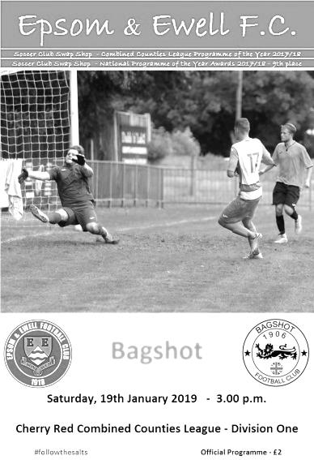
Late five goal blitz shatters Bagshot resistance

Just three weeks ago I wrote that we were due a day where we would take our chances. We might have had to wait a while in this match before it eventually happened but to score five goals in the final eighteen minute plus injury time was worth waiting for.

Our visitors were missing a few of their regulars, which left them limited on their bench and probably contributed to their late demise too, but we were missing Reisse Griffin and although Jamie Watts had completed his suspension, he was unavailable also. In addition the previously ever-present Lloyd Connelly was still struggling with an injury picked up the week before against Ash United and he spent the match on the bench. Luke Elgar and Ryan Sullivan both returned to the starting eleven while Billy Carney made his first start with Ben Chick returning to the bench, although he would be well involved later on.

We got off to a flying start with the players no doubt well aware where we went wrong the previous Saturday and took the lead in the 7th minute when Louis Chin was brought down 30 yards out. Rob Hendry delivered a curling set piece and Elgar was there to get on the end of it, guiding the ball past Adrian Giles in the Bagshot goal from the edge of the six yard box.

We nearly had another just two minutes later when Liam Roberts got through on the left. His cut back beat the defender who then brought him down in the box, but the referee wasn't convinced and then booked our man for complaining. It looked harsh, although having spoken to the referee afterwards, he felt that Roberts had made a meal of it and that was why it wasn't given. Looking back at the video I can see why he made that decision now, although I still think there was definitely enough for a penalty!

A Bagshot player received a similarly harsh yellow card for complaining after he also appeared to be fouled and we went 2-0 up in the 17th minute. This time Elgar fed Hendry with a 40 yard clearance that dropped over a defender and our in-form striker ran through and finished clinically into the bottom corner from twelve yards.

Louis Chin made an important block on the half hour but the addition of their Manager Phil Ruggles as a substitute made the contest more even and the visitors started to threaten. We had a warning in the 39th minute when Kai Parton-Edey struck a loose ball straight at Conor Young. However, we didn't heed the warning and within seconds a ball in from the right was met at the far post by Josh Ogunseye and he knocked the ball past the exposed Young in the 40th minute to bring them back into the match.

We nearly made it 3-1 in injury time when Roberts got through on the left but was brought down on the edge of the area, but again no foul was given. Carney drove hard and low from the edge of the box but Giles was able to gather the ball at the second attempt with Hendry incoming. We were good value for the lead at the half but warning signs were also present.

In fact, we started off the second half a little wobbly and the chances we created resulted in efforts well off target from Hendry and Roberts. However, we should have extended the lead in the 63rd minute when Chin sent over a pinpoint cross from the right but Carney's header from close range was straight at Giles. Chick replaced Roberts and nearly scored with his first touch as Bennett sent a deep ball to the far post but his contact actually sent the ball back across the six yard box where Hendry then hit the foot of the post with his header. Elliott Thompson followed that with a clever run but fired just over from the edge of the box.

The visitors still threatened on occasions and fired a long range free kick that was deflected for a corner but we cleared the danger and a five goal blitz soon followed; starting in the 72nd minute when Bennett cut in from the right and found Sullivan with a low pass who then found Chick on the left and he cut inside his defender and finished easily. Two minutes later it was 4-1 as Chick crossed from the left for Carney to head the ball into the roof of the net from close range.

Young made a good low save from Lekan Osideko before we responded with a long ball that the Bagshot defence had trouble with. Hendry nodded the ball onto Chick whose shot was tipped over the bar by Giles. In the 86th minute though we had another opportunity when Hendry was clumsily bundled over in the box. Bennett spoilt his 100% record from the spot a minute later as Giles guessed the right way, but the ball came back out and Bennett knocked in the loose ball. Two minutes later a smart pass from Thompson put Chick through and from twenty yards he realised that Giles was off his line and curled the ball around him and into the vacant net.

We completed the scoring in the 95th minute when substitute Sam Morgan set Bennett off down the right and his low ball in was swept past Giles by Hendry from close range to make it 7-1 which it must be admitted was a little harsh on Bagshot who contributed plenty to this match and were in my opinion a better side than the Ash team we'd played seven days earlier until that final period.

Ultimately the difference between our team and the clubs higher up is that they are slightly more consistent than us and this was highlighted for me on Saturday by a superb first 30 minutes, followed by a very wobbly period either side of half time and then our strong finish, which is indicative of our season so far really. We can beat anyone and even be quite devastating at times as Bagshot found out this weekend and it must be pointed out that they had held Champions elect Bedfont & Feltham to a draw just seven days previously. However, this result could all be for nothing if we then throw in a weak performance when we visit Godalming next weekend. Let's hope we can keep this form up, which it should be pointed out now represents just one loss in fifteen matches.

Epsom and Ewell: Conor Young, Louis Chin, Luke Elgar, Ryan Sullivan, Adam Heagney, Elliott Thompson, Bobby Bennett, Scott Murphy (c), Rob Hendry, Billy Carney,
Liam Roberts

Subs: Ben Chick for Roberts (60), Roy Gayle for Sullivan (77),
Sam Morgan for Carney (79)

From behind the goal
Godalming Town 1-3 Epsom & Ewell
Combined Counties League - Division One - Saturday 26th January 2019

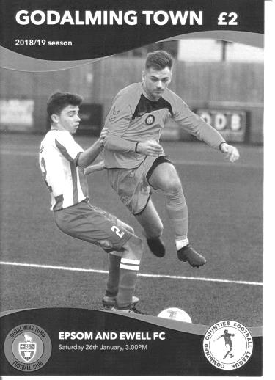
Salts find a way to win at Wey Court

Whisper it quietly but our boys are putting together a bit of a late run! Our latest league win at Godalming Town gives us a record of eight matches unbeaten with just one defeat in 16 matches and despite a mid-match wobble we came through and finished strongly in the end to maintain our record.

Godalming came into this match on a run of three heavy defeats and had brought in some new players, one of whom, Reece Weekes had an impressive outing. We made just two changes from last week's heavy win over Bagshot with Ben Chick coming in for the injured Liam Roberts and Lloyd Connelly coming back into the starting eleven for Adam Heagney who was unwell and as a result his ever present run, the last one for our club this season, came to an end.

We started well with Billy Carney putting Bobby Bennett through on goal in the second minute and he struck his shot well but Jordan Knight made a good save with his legs and the danger was cleared. Two minutes later Carney then set up Rob Hendry for a shot on the turn which was on target but was at a good height and Knight made an easy save.

The play then became fairly even for a while with the hosts even shading the possession, but it counted for nothing in the 18th minute as Carney's flick on put Hendry through and he struck the ball low across Knight into the bottom corner from twelve yards to put us ahead. Then Joseph Lewis for the home side found himself in the book for a foul which would have consequences for the defender later on.

Godalming were still contributing plenty to this match and their impressive Captain Jack Howard was just wide with a low shot and on the half hour they probably should have equalised when Donte-Lodge-Francis managed to escape Connelly for about the only time in the match. Through on goal in a central position he ran in on Conor Young, but our man stood up well and made the save with his left foot, with the subsequent corner coming to nothing.

Unfortunately Elliott Thompson picked up an injury around the half hour mark and was replaced by Roy Gayle. We continued to look dangerous when going forward though and Chick's curling delivery from the right was just beyond the incoming Hendry. Carney then made another dangerous run before setting up Hendry whose low shot was deflected across goal and just wide of the post by a covering defender. It could have gone anywhere!

Two minutes from half time Luke Elgar made a fine run. He set up Bennett who had switched to the left wing and he ran in before pulling the ball back where Elgar had continued his run. His shot was blocked but that didn't stop our man from winning the ball again and indeed

once more but the ball was cleared away in the end by a grateful defender. Then moments before the players went off Bennett sent a stinging shot at goal that Knight could only parry but the loose ball was cleared and we went in just the one goal ahead.

As we found out against Ash not long ago a one goal lead can prove vulnerable. We started the second half slowly with Weekes sending two shots just above Young's goal. He then sent a ball across the face of our goal but fortunately there was no one there to finish it off. The pressure was building though and they equalised in unusual circumstances in the 55th minute. We had looked fairly solid defensively to this point, but a long ball pumped over the top left Oliver Stevens in acres of space and Young was the only one who could stop him. The ball bounced up but it was outside the area so our keeper couldn't use his hands and Stevens outjumped him to the high ball and rolled it into the vacant net.

Now it was all about the response. This equaliser was deserved, but our boys stepped up a gear from this point and killed the home side's momentum within five minutes. Carney made another run, reminiscent of a former striker from a few years back by the name of James Cottee, although there were also references made to another striker from the late eighties in Andy Webster. He broke tackles before the ball was intercepted by a defensive challenge, but it fell to the substitute Hakim Griffiths on the left and he controlled the loose ball before sending it back into the danger area where Carney had continued his run and he finished low into the bottom corner from eight yards in the 60th minute.

Bennett probably should have made it 3-1 ten minutes later when he ran on to a Carney pass but his shot was well blocked by Knight one on one from close range. In the end it didn't matter as another Bennett run was ended by a trip in the box in the 73rd minute and he tucked away the resultant penalty, following which Lewis had something to say to the referee and received a second yellow card for his comments. The home side were clearly unhappy about the award but both the Assistant and the Referee felt it was a penalty and they indicated almost simultaneously. For what it's worth, I thought it was a penalty too and Bennett ensured that we have now scored ten penalties this season; a club record, with our striker now equalling Kyle Hough's record of nine in a season with plenty of time left.

Following the dismissal we were well on top for the remainder of the match. A Bennett volley was well tipped over by Knight, only for the referee to award a goal kick, overruling his Assistant in the process. However, I thought the official had a good game otherwise, definitely for the first seventy-five minutes anyway, and his application of the advantage law was one to use as an example to other officials.

In the closing moments Hendry had a low shot easily saved while Carney saw a shot blocked and we picked up a couple of late bookings for Sam Morgan and Ryan Sullivan; the latter presumably for persistent small fouls, as the challenge itself didn't appear to warrant a card on its own. Still, at the end of the match our players can be proud of their response to conceding, although obviously it would have been better if we had already put the game to bed by that point!

Epsom and Ewell: Conor Young, Louis Chin, Luke Elgar, Elliott Thompson,
Lloyd Connelly, Ryan Sullivan, Bobby Bennett, Scott Murphy (c), Rob Hendry,
Billy Carney, Ben Chick

Subs: Roy Gayle for Thompson (33), Hakim Griffiths for Chick (53),
Sam Morgan for Elgar (79)

This Day in History - 2nd February
Date | Day | Competition |  | Opponents |  | Scorers
02/02/29 | Sat | Surrey Senior Cup  1 replay | A | Westminster Bank | 5-1 | R.Marlow, W.Challis (2), F.Behn, G.Carmichael
02/02/35 | Sat | London League | A | Park Royal | 2-5 | H.Pullen (2)
02/02/46 | Sat | London League | H | Uxbridge | 4-3 | R.Buller (2), G.Brogdale, E.Watkins
02/02/57 | Sat | Corinthian Memorial Shield 2 replay | A | Slough Town | 5-2 | J.Bangs (3), D.Hermitage, o.g.
02/02/74 | Sat | Surrey Senior League | A | Frimley Green | 2-0 | C.Rose (2)
02/02/80 | Sat | Isthmian League 1 | H | St Albans City | 2-0 | F.Samoth, T.Tuite
02/02/82 | Tue | Isthmian League 1 | H | Farnborough Town | 1-2 | T.Tuite
02/02/85 | Sat | Isthmian League  Premier Division | H | Billericay Town | 1-0 | S.Hill
02/02/91 | Sat | Isthmian League 2s | A | Cove | 1-0 | T.Tweedy
02/02/93 | Tue | Associate Members Trophy 1 | A | Southall | 2-3 | M.Alcindor (2)
02/02/02 | Sat | Isthmian League 3 | H | Croydon Athletic | 2-2 | M.Freeborough, J.Buckley
02/02/08 | Sat | Combined Counties Premier Division | A | Raynes Park Vale | 2-2 | C.Heuston (2)
02/02/10 | Tue | Combined Counties Premier Division | H | Bedfont | 2-1 | K.Hough, A.Amfo-Brobbey
02/02/13 | Sat | Combined Counties Premier Division | H | Dorking | 3-2 | K.Hough, J.Hatfield, B.Hayward
02/02/16 | Tue | Combined Counties Premier Division | H | Redhill | 3-0 | K.Hough, T.Neale, M.Ferdinando
Historical Decades
90 years ago – Epsom Town F.C.
02/02/29 | Sat | Surrey Senior Cup 1 replay | A | Westminster Bank | 5-1 | R.Marlow, W.Challis (2), F.Behn, G.Carmichael
80 years ago – Epsom F.C.
04/02/39 | Sat | London League | A | P.O.Engineers | 2-1 | G.Collins, B.Solly
70 years ago – Epsom F.C.
29/01/49 | Sat | London League | H | Leavesden | 5-1 | B.Cutter (4), F.Chitty
60 years ago – Epsom F.C.
31/01/59 | Sat | Corinthian League | A | Leatherhead | 0-3
50 years ago – Epsom & Ewell F.C.
01/02/69 | Sat | Athenian League 2 | A | Edmonton | 0-1
40 years ago – Epsom & Ewell F.C.
03/02/79 | Sat | Isthmian League 1 | A | Walton & Hersham | 4-2 | T.Tuite (2), G.Archer (2)
30 years ago – Epsom & Ewell F.C.
04/02/89 | Sat | Isthmian League 2s | A | Feltham | 1-1 | L.Harding
20 years ago – Epsom & Ewell F.C.
04/02/99 | Thur | Assoc Members Trophy 3 | A | Banstead Athletic | 4-1+ | A.Rawlinson, S.Grant, K.Webb, o.g.
10 years ago – Epsom & Ewell F.C.
31/01/09 | Sat | Combined Counties Premier Division | H | Sandhurst Town | 2-1 | R.Burns, D.Marvell

History Corner - 2nd February
90 years ago today we welcomed Westminster Bank for a Surrey Senior Cup replay. Back then, works sides were very strong and we met Lloyds, Barclays and the Westminster Bank back in those days. The Westminster Bank was a forerunner of the bank we know these days as Nat West and we would meet them once again under that name in the Seventies, but this team had already held us to a goalless draw and although the replay, also at West Street, was won 5-1 their draw should be placed in some perspective, as our next match in the competition resulted in a 3-1 win over Isthmian League side Casuals, before we battered mighty Wimbledon 4-1 to reach the Final itself!

70 years ago this week Leavesden visited West Street for a London League match and were crushed 5-1. The Leavesden Hospital side had been a very powerful one back in the Thirties but were beginning to wane by this time and four goals were scored by regular defender Bill Cutter, playing as a centre-forward, while the other came from future Manager Fred Chitty.

62 years ago today we were a free scoring side, about to register 100 goals for the season a couple of weeks later and the main reason for this was Johnny Bangs, who would score 53 times for us despite only joining in mid-September. He got three this day as we secured our passage to the Corinthian League Memorial Shield Semi-Final with a 5-2 replay win at Slough’s long departed Dolphin Ground. We would go on to reach the Final where an early injury to Bangs would prove crucial as Maidenhead United would defeat us 2-0 at Meadowbank in the Final.

45 years ago today a pair of Colin Rose goals enabled us to win 2-0 at Frimley Green in a Surrey Senior League match. We visit Frimley in three weeks and it should be pointed out that this 2-0 win is the worst result we have ever had there! In five visits we have a perfect record and followed the 2-0 with a 3-0, two 5-1 wins and a 5-0 victory. Hopefully we can keep that record up over at Frimley Recreation Ground!

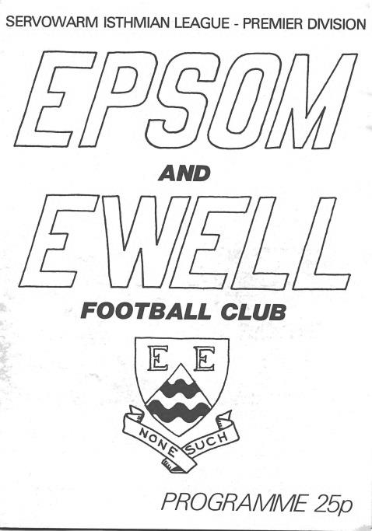
37 years ago today we defeated Billericay Town in the Isthmian League Premier Division. This match is very memorable to me as we had lost over in Essex 1-0 the previous October in a match we had dominated and missed a penalty in. They had been very negative and stopped everything we could throw at them and were threatening to do the same in this return fixture. Until the 92nd minute, that is, when a ball from the right wing was headed in by my former P.E. teacher at Epsom High School, Steve Hill. Maybe it was relief at the late winner, or maybe just youthful exuberance (probably both), but I’m not sure if I have ever given a bigger shout when that one hit the net. The local papers summed it up in their report by saying “Billericay are not an attractive team to watch”! (see programme pictured)

17 years ago today we recovered a two goal deficit to secure a 2-2 draw at home to Champions elect Croydon Athletic. Promotion would also follow for us that season.

11 years ago today a very late Chad Heuston header, his second of the match, enabled us to get away from Grand drive with a 2-2 draw against Raynes Park Vale. It was a close call though after we had thrown an early lead.

How we stand – Locally and Nationally – inc Sat 26/01/19
Here is the latest update on where we all stand.

To summarise for new readers, there are 28 promotion places currently available at Step Six, with 358 teams battling away for those spots. The Champions of each League are guaranteed a promotion, with the best nine runners-up also going up. This number looks as though it will rise by four due to no likely promotions from the South West Peninsula League and the now confirmed folding of Isthmian League Thamesmead Town and voluntary demotion of Aylesbury FC, but this could increase further. For now we’ll continue to look at the 28 and anything else will be a bonus!

In our previous update, we were listed as 78th Nationally but since then we have drawn with Ash United, but beaten Bagshot and Godalming and have moved up to 69th place.

Below is our current League table sorted by points per game, while across the page we have the overall top ten and most importantly the 28 clubs who would go up if the season ended right now.

Frimley Green, currently holding the runners-up spot in our League on points per game have the 15th best record of the 19 second placed teams. Our league is so competitive right now that it may well prove to be just the Champions that go up, but I’ll keep updating the position here while we remain involved.

Combined Counties League Division One Table – by PPG
 | Pld | W | D | L | Pts | GD | PPG | Pos
Bedfont & Feltham | 22 | 15 | 5 | 2 | 50 | 49 | 2.27 | 2
Frimley Green | 24 | 16 | 5 | 3 | 53 | 21 | 2.21 | 1
Sheerwater | 23 | 15 | 4 | 4 | 49 | 24 | 2.13 | 3
Farnham Town | 21 | 13 | 4 | 4 | 43 | 27 | 2.05 | 5
Epsom & Ewell | 24 | 15 | 3 | 6 | 48 | 24 | 2.00 | 4
Tooting Bec | 22 | 12 | 5 | 5 | 41 | 23 | 1.86 | 6
Sandhurst Town | 21 | 11 | 3 | 7 | 36 | -2 | 1.71 | 9
Ash United | 24 | 11 | 5 | 8 | 38 | 8 | 1.58 | 7
Dorking Wanderers Res | 26 | 11 | 4 | 11 | 37 | -1 | 1.42 | 8
British Airways | 22 | 9 | 4 | 9 | 31 | 1 | 1.41 | 10
Chessington & Hook Utd | 21 | 8 | 5 | 8 | 29 | -2 | 1.38 | 11
Bagshot | 26 | 7 | 4 | 15 | 25 | -44 | 0.96 | 12
Godalming Town | 22 | 6 | 3 | 13 | 21 | -21 | 0.95 | 13
FC Deportivo Galicia | 21 | 5 | 3 | 13 | 18 | -6 | 0.86 | 14
Eversley & California | 21 | 5 | 2 | 14 | 17 | -15 | 0.81 | 15
Cove | 22 | 4 | 2 | 16 | 14 | -22 | 0.64 | 16
Kensington Borough | 22 | 3 | 5 | 14 | 14 | -32 | 0.64 | 17
Fleet Spurs | 22 | 4 | 0 | 18 | 12 | -32 | 0.55 | 18

Step Six Table – by PPG – Top 10
 | Which League? | Pld | Pts | GD | PPG | Current Pos.
Harefield United | SSML | 23 | 65 | 56 | 2.83 | 1
Easington Sports | HellW | 11 | 30 | 41 | 2.73 | 2
AFC Stoneham | Wess | 20 | 54 | 58 | 2.70 | 2
Tavistock | SWP | 23 | 59 | 45 | 2.57 | 2
Billingham Town | Northern | 27 | 69 | 53 | 2.56 | 1
Cheltenham Saracens | HellW | 13 | 33 | 45 | 2.54 | 1
Racing Club Warwick | Midland | 21 | 53 | 49 | 2.52 | 3
Steyning Town | Scomb | 21 | 53 | 36 | 2.52 | 1
Selston | E.Mids | 25 | 63 | 55 | 2.52 | 1
Anstey Nomads | UCL | 23 | 57 | 61 | 2.48 | 2
Epsom & Ewell | We are 69th | 24 | 48 | +24 | 2.00 | 4

Step Six Table – The 28 Promoted Clubs if the season ended today
The 19 Champions – Based on current PPG
 | Which League? | Pld | Pts | GD | PPG | Current Pos.
Harefield United | SSML | 23 | 65 | 56 | 2.83 | 1
Easington Sports | HellW | 11 | 30 | 41 | 2.73 | 2
AFC Stoneham | Wess | 20 | 54 | 58 | 2.70 | 2
Tavistock | SWP | 23 | 59 | 45 | 2.57 | 2
Billingham Town | Northern | 27 | 69 | 53 | 2.56 | 1
Racing Club Warwick | Midland | 21 | 53 | 49 | 2.52 | 3
Steyning Town | Scomb | 21 | 53 | 36 | 2.52 | 1
Selston | E.Mids | 25 | 63 | 55 | 2.52 | 1
Anstey Nomads | UCL | 23 | 57 | 61 | 2.48 | 2
Cheddar | Western | 22 | 54 | 42 | 2.45 | 2
Tividale | W.Mids | 29 | 71 | 80 | 2.45 | 1
Longridge Town | NWCN | 27 | 66 | 70 | 2.44 | 1
Burnham | HellE | 17 | 41 | 39 | 2.41 | 1
Harleston Town | EastN | 25 | 59 | 49 | 2.36 | 1
May & Baker Eastbrook | EastS | 20 | 46 | 26 | 2.30 | 5
Bedfont & Feltham | CCL | 22 | 50 | 49 | 2.27 | 2
Erith & Belvedere | SCEFL | 19 | 43 | 35 | 2.26 | 4
Campion | NCEL | 24 | 54 | 30 | 2.25 | 1
Rylands | NWCS | 25 | 54 | 54 | 2.16 | 1
And the 9 best Runners-Up currently
Cheltenham Saracens | HellW | 13 | 33 | 45 | 2.54 | 1
Heather St Johns | Midland | 24 | 59 | 69 | 2.46 | 1
Amesbury Town | Wess | 22 | 54 | 40 | 2.45 | 3
Alfold | Scomb | 21 | 51 | 39 | 2.43 | 2
Newark Flowserve | E.Mids | 25 | 60 | 70 | 2.40 | 2
Avro | NWCN | 25 | 60 | 48 | 2.40 | 2
Lutterworth Town | UCL | 24 | 57 | 73 | 2.38 | 1
Plymouth Argyle Reserves | SWP | 25 | 59 | 73 | 2.36 | 1
Keynsham Town | Western | 24 | 56 | 43 | 2.33 | 1

Centre page for results

Centre page for results

CCL Division One Club Directory
AC LONDON: Telephone: 0208 660 5491 - Colours: Orange/Black/Black
Ground: Whyteleafe FC - 15 Church Road, Whyteleafe. CR3 0AR

ASH UNITED: Telephone: 01252 344264 - Colours: Green with Red Trim/Green/Green
Ground: Shawfields Stadium, Youngs Drive, Shawfields Road, Ash, Aldershot. GU12 6RE

BAGSHOT: Telephone: 01252 623804 - Colours: Yellow/Black/Black
Ground: Fleet Town FC - Calthorpe Park, Crookham Road, Fleet. GU51 5FA

BEDFONT & FELTHAM: Telephone: 0208-890 7264 - Colours: Yellow/Blue/Blue

Ground: The Orchard, Hatton Road, Bedfont. TW14 9QT

BRITISH AIRWAYS: Telephone: 0208-890 7264 - Colours: Sky Blue/Navy Blue/Navy Blue
Ground: Bedfont & Feltham FC - The Orchard, Hatton Road, Bedfont. TW14 9QT

CHESSINGTON & HOOK UNITED: Telephone: 01372-602263 Colours: All Blue
Ground: Chalky Lane, Chessington. KT9 2NF

COVE: Telephone: 01252 543615 Colours: Yellow/Black/Black
Ground: Oak Farm, Squirrel Lane, Cove GU14 8PB

DORKING WANDERERS RES Telephone: 01306 400151 - Colours: Red & White Stripes/ Blue/ Red
Ground: Meadowbank Stadium, Mill Lane, Dorking. RH4 1DX

EPSOM & EWELL Telephone: 01737-553250 - Colours: Royal Blue & White Hoops/Royal Blue/Royal Blue - Ground: Chipstead FC, High Road, Chipstead. CR5 3SF

EVERSLEY & CALIFORNIA Telephone: 0118 973 2400 - Colours: - White & Royal Blue Hoops /Royal Blue/ Royal Blue - Ground: Fox Lane, off Reading Road, Eversley. RG27 0NS

FARNHAM TOWN Telephone: 01252 715305 - Colours: - Claret & Sky Blue /White/ Claret & Blue
Ground: Memorial Ground, Babbs Mead, West Street, Farnham. GU9 7DY

FC DEPORTIVO GALICIA Telephone: 0208 831 9067 - Colours: Royal Blue/Royal Blue/White
Ground: Bedfont Sports FC - Bedfont Sports Club, Hatton Road, Bedfont. TW14 9JR

FLEET SPURS Telephone: 01252 662810 - Colours: Dark Blue with Red Trim/Dark Blue/Dark Blue
Ground: Kennels Lane Farnborough. GU14 0ST

FRIMLEY GREEN Telephone: 01252 835089 - Colours: All Blue
Ground: Frimley Green Recreation Ground, Frimley Green Road, Frimley. GU16 6JY

GODALMING TOWN Telephone: 01483 417520 - Colours: Yellow/Green/Yellow
Ground: Wey Court, Meadrow, Godalming. GU7 3JE

KENSINGTON BOROUGH Telephone: 01372 360151 - Colours: All Blue
Ground: Leatherhead FC – Fetcham Grove, Guildford Road, Leatherhead. KT22 9AS

SANDHURST TOWN Telephone: 01252 878768 - Colours: Red & Black Stripes/Black/Black
Ground: Bottom Meadow, Sandhurst Memorial Park, Yorktown Road, Sandhurst. GU47 9BJ

SHEERWATER Telephone: 01483 772470 - Colours: Royal Blue & White/Royal Blue/Royal Blue
Ground: Woking FC - Laithwaite Community Stadium, Kingfield, Kingfield Road, Woking. GU22 9AA

TOOTING BEC Telephone: 0208 540 8843 - Colours: Black & White Stripes/White/White & Black
Ground: Raynes Park Vale FC – Prince George’s Playing Fields, Grand Drive, Raynes Park. SW20 9DZ

Farnham Town – History
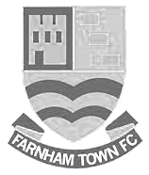
Farnham Town Football Club is a senior level football club based In Farnham, Surrey, England.

Established in 1906 through the merging of Farnham Bungs (the Farnham Brewery) and the Farnham Star. The club was one of the founder members of the London Spartan League in 1975. They reached the Fourth Round of the FA Vase in the 1976-77 season.

At the end of the 1979/80 season Farnham Town left the London Spartan League and applied to the Combined Counties League, their application was accepted and they finished 4th in their first season. The 1986/87 season saw Farnham take second place to Ash United in the league campaign. The glory days finally arrived in the 1990/91 season when the club won the league title. In the 1991/92 season, the Town got a clean sweep of the major trophies by winning the Combined Counties Premier League, the Dan Air Elite Cup and the Dan Air Challenge Cup. Having won the league, the club applied and were accepted to the Diadora League, however funds for necessary ground improvements could not be generated which resulted in the club not having a league to play in for the 1992/93 season.

In 1993/94 Farnham Town were accepted back into the Combined Counties League where they continue to ply their trade. From 1995-1998 Farnham finished in the top six of the Premier Division for three consecutive seasons, in 1998-99 they finished in 13th position, then 10th in 1999-2000 before suffering relegation from the Premier Division in 2000-2001 season. They bounced straight back the following season but then endured four tough seasons back in the Premier Division, with bottom four finishes every season culminating in relegation back down to Division One in 2005-2006. Again, the club bounced straight back and in 2006-2007 they won the Division One title under the guidance of Barry Bridger, but were denied promotion due to the Memorial Ground not meeting the desired grading by the league. The club then spent another four seasons in Combined Counties Division One.

Farnham gained promotion from Combined Counties Division One in the 2010-2011 season after finishing second behind Worcester Park. In Paul Tanner’s first season at the helm he gained automatic promotion back to the Premier Division at the first attempt, which after only retaining four members of the side from the previous year’s squad - who finished mid-table, was quite an achievement. Paul Tanner’s side also won the Combined Counties Fair Play Award for 2010-2011 after going the whole season without having a man sent off, a record to be proud of. In a very successful year for the club on the whole, Dean Nelson’s reserve side finished second behind Mole Valley in the Combined Counties Reserve Division, improving on fourth position the previous season. Farnham Ladies also finished second in their respective league to cap quite a remarkable season in Geoff Chapple’s final season as Chairman. In 2011, Ray Bridger took over as chairman from Geoff Chapple.

The 2015/16 season saw the club lift the Cherry Red Records Premier Challenge Cup whilst also reaching the final of the Aldershot FA Senior Cup

The 2017/2018 was ultimately one of disappointment to the club. A good start saw the club go on its best FA Vase run in decades, the defeat of higher league opposition in the County Cup and reaching 12th place on the back of a long undefeated run by early November. However defeat in the last minute of the FA Vase 2nd Round to Bridgwater Town marked a significant turning point and the club didn’t win a single league match between 8th November and the season’s end. This run led to the resignation of long serving manager, Paul Tanner, in February with first Paul Bonner and then Emmanuelle Boudine brought in to try and attempt to reverse the club’s fortunes but alas it wasn’t to be and The Town ended the season in last place and were relegated to the Combined Counties Division One. The one highlight of the latter half of the season however was the progression to the semi-finals of the Aldershot Invitation Cup where they lost to eventual winners Hartley Wintney

There is renewed optimism around the club now however as the close season has seen the appointment of Luke Turkington as manager, and there are exciting plans for the club both on & off the field as they look to bounce back as quickly as possible.

Latest Result Grid
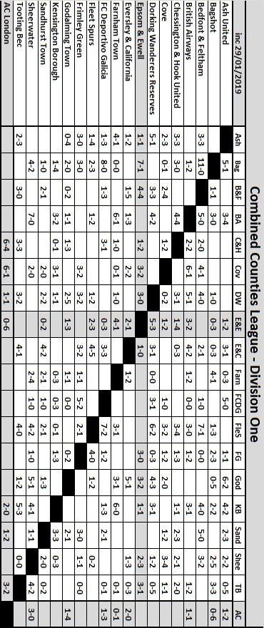

Previous Managers
In our latest instalment we reach the pinnacle of our story!

Adrian Hill – March 1982 – May 1985
Alan Webb – May 1985 – Sept 1986

How do you follow Pat O’Connell?

This was the question most fans were asking as the home match with Hornchurch on Saturday 6th March was postponed (although we received a token fine of £50 from the Isthmian League for our trouble) so that we could have a supporters meeting at the clubhouse which was Chaired by Peter Smith, our Chairman.

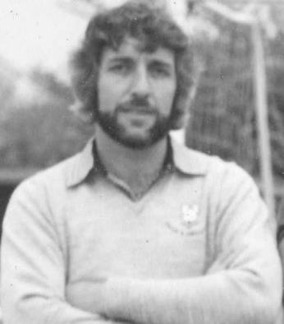
What Smith maybe didn’t realise at the time was how successful O’Connell’s replacement would prove to be. Adrian Hill, born in Ruislip on 15th April 1945 was a central defender with much experience at Croydon, Redhill, Leatherhead and latterly Epsom & Ewell had left our club in 1980 to become Player / Manager at Dorking. He jumped at the chance to Manage at the higher level and brought keeper Steve Chapman and Physio Dennis Kenny with him. Chapman was best known for playing in goal for Charlton Athletic, while Ada as he was affectionately known was a refrigeration engineer.

Inevitably Hill had to move quickly to bring in new players from almost anywhere. To his credit, he didn’t raid the Dorking club, but picked up players from many different teams. Four came from Whyteleafe, one of whom, Alan Pardew, would play four times for us before eventually ending up in the Football League where he would also go on to be Manager at many clubs.

The first match after the O’Connell walkout was a 2-0 home defeat against Hampton, but the second on Saturday 13th March 1982 resulted in a 1-0 win over Aveley with a Kelvin Roots penalty securing the points at West Street.

We managed to survive fairly comfortably that season, although 1982/83 was a little more concerning. We were close to the relegation positions for a while but a 5-0 win over bottom club St Albans City coupled with the news that only one team would go down, lightened the mood just before Christmas and five consecutive goalless draws in January and February, which weren’t exciting but did provide five points, helped us inch to safety. In fact, the defensive run continued for a while and Steve Chapman set two club records in the process; one of ten hours 50 minutes without conceding a goal in any match and one of ten hours 33 minutes without conceding at West Street; a run which would not end until April!

Survival was not an issue in the end and we hit the ground running in 1983/84 with a goal after 27 seconds of our opening match against Boreham Wood in an eventual 2-1 win. We remained amongst the top sides all season, although never touched the top spot. Then in March 1984 we lost at home for the first time in a League match for fifteen months. We had gone the whole of 1983 unbeaten at home in the League!

We bounced back immediately though and finished strongly, with players of the calibre of Paul Harding, Steve Milton and Murray Jones in our line-up who would all go on to play in the Football League, added to the free scoring Steve Hill, who notched 38 goals and a solid defence, we finished as runners-up to Champions Windsor & Eton on a memorable night on 1st May 1984 when we won 2-1 at Farnborough Town and had the added bonus of a Surrey Senior Cup Final appearance, losing to Premier Division Sutton United at Imber Court.

Finally, we had reached the Isthmian League Premier Division! Pat O’Connell had aimed to do it in ten years and ultimately it took the club eleven, but no one was counting! We strengthened for the new season with the return of former scoring legend Tommy Tuite and his partnership with Hill would be record breaking and remains the greatest we have had at the club, despite the recent claims of Robbie Burns and Kyle Hough.

We started off slowly with an opening day defeat to a good Hayes team and the winless run extended until November with narrow defeats all over the place, including a fluky 4-3 loss at Worthing and another similar match that was lost 5-4 at Sutton on consecutive September Tuesdays. A 3-0 win over Hitchin on 3rd November got us up and running and three days later we destroyed Leytonstone & Ilford 5-1 on their own ground. Hill and Tuite would score 67 goals between them with Tuite getting 34 to Hill’s 33 and we survived in a very comfortable 13th place.

However, Hill had decided he could go as far as he could at the club and resigned to take the job at another of his old clubs, Croydon. Much of the team went with him as they would achieve a fourth place finish in the Premier Division during 1985/86, although Tuite would remain and the baton was passed very easily by the Committee to our successful Reserve Team Manager and long serving player Alan Webb. There will be more about Ada in future editions!

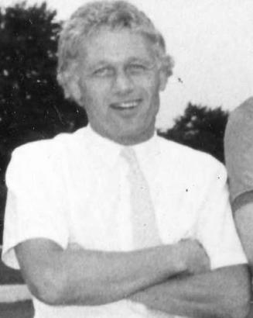
Webb was born on 14th July 1947 in Fulham and had joined us from Tooting & Mitcham United in 1972, becoming the only player at the club to play in the Wembley F.A. Vase Final who had pre-dated O’Connell at the club, with exception of Johnny Eales. He went on to make 352 appearances for the club, which placed him seventh on the all-time list at the time of his final match and he still sits eighth even now with many more matches played these days. He had taken the Reserves to Second place in the Suburban League and was a popular choice.

However, he had to build almost a new team from scratch with not a great deal of money. This was a tough ask, and whilst some players remained like Chris Hills, Dave Hanks and Robin Lewis, all former Youth team players at the club, we were to rely on a number of unproven names. Five players made their debuts at Walthamstow Avenue on 24th August 1985 as we led 2-0 but failed to hold on and had to settle for a 2-2 draw. An own goal gave us the points against Bognor Regis Town the following Tuesday in a match which contained an appearance from former Professional Trevor Lee and then we had the Hendon rollercoaster as we trailed 3-0 at West Street but reduced the gap to 2-3 by the half and went on to win 5-3.

Yeovil Town were the only side above us as we sat in second place in the entire Isthmian League and their defeat at Croydon on the Monday gave us a chance to go top if we could defeat Dulwich Hamlet on Tuesday 3rd September. However, the Hamlet won 3-0 and things went steadily worse as we slipped down the table, eventually finding ourselves bottom where a 4-2 home defeat to Wokingham Town on the final day of the season sealed our fate, despite the addition to the playing ranks of former Sutton United and Dagenham legend Ricky Kidd in October of 1985.

Webb was retained for the 1986/87 season but lasted just five matches before being sacked as Sussex League Three Bridges knocked us out of the F.A. Cup and he was replaced by Kidd. Webb was quoted as saying he felt he had been stabbed in the back, but I also heard that the club were concerned he had gone on holiday to America at a time when it was crucial to recruit new players. Webb remains at number 1 on my list for former Epsom people I would like to talk to, mainly to get his version of events here as much as for his other exploits!

Player Sponsorship
Here is the latest list for 2018/19, with new photos showing all of our players and Management that are available for sponsorship.

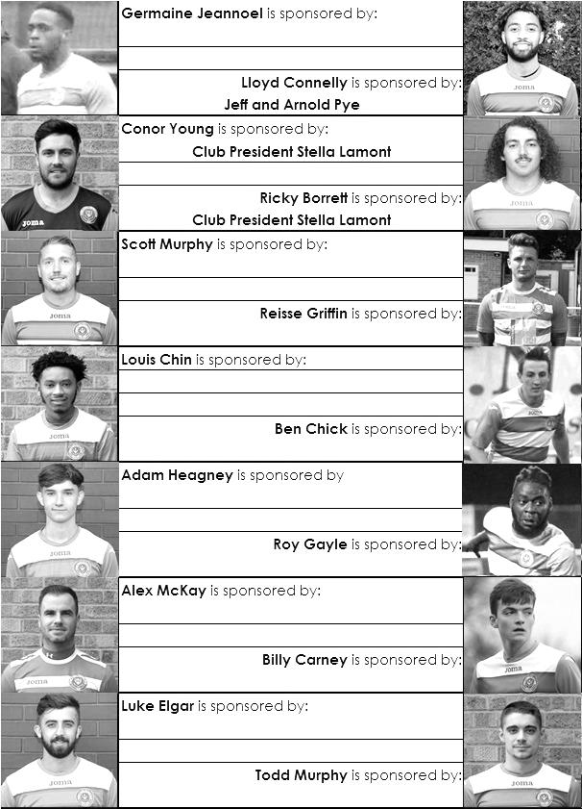

Sponsorship costs just £40 and it is easy to do. Just select a player who has not been previously sponsored and let a Committee Member know that you would like to sponsor them. Beware though. Until we have received the money it is possible for someone to jump in front of you, so don’t delay, sponsor today!

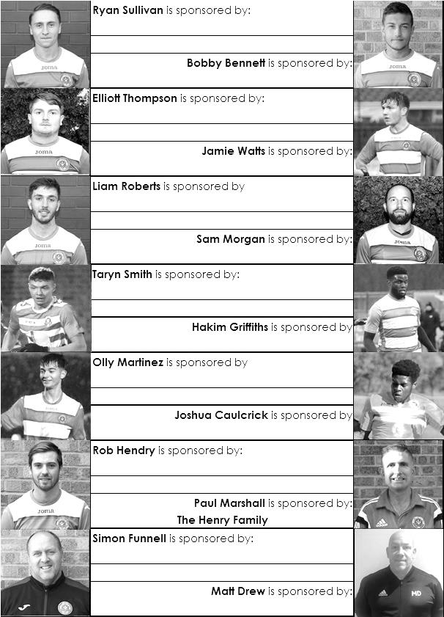

EL Records Premier Challenge Cup
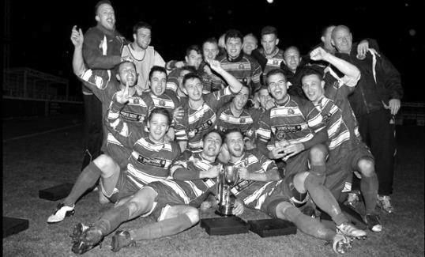
Second Round
Bedfont & Feltham | 2-0 | Tooting Bec
Sheerwater | 1-0 | Balham
Ash United | 2-3 | Fleet Spurs
Frimley Green | 0-2 | Guildford City
Godalming Town | 2-0 | Dorking Wanderers Reserves
Abbey Rangers | 3-0 | Redhill
FC Deportivo Galicia | 5-0 | AC London
Cobham | 0-3 | AFC Hayes
Abandoned after 88 minutes due to serious player injury - Match awarded to AFC Hayes
CB Hounslow United | 4-1 | Badshot Lea
Hanworth Villa | 2-1 | Sandhurst Town
Epsom & Ewell | 1-0 | Bagshot
Sutton Common Rovers | 4-2 | Southall
Chertsey Town | 3-2 | British Airways
Eversley & California | 1-5 | Knaphill
Banstead Athletic | 4-3 | Colliers Wood United
Spelthorne Sports | 2-1 | Raynes Park Vale
Third Round
FC Deportivo Galicia | 0-2 | Sutton Common Rovers
AFC Hayes | 0-1 | Bedfont & Feltham
Epsom & Ewell | 12/2 | Godalming Town
Sheerwater | 0-3 | Banstead Athletic
Guildford City | 0-2 | CB Hounslow United
Spelthorne Sports | 0-1 | Hanworth Villa
Knaphill | 3-1 | Fleet Spurs
Chertsey Town | 1-2 | Abbey Rangers
Quarter Finals
Abbey Rangers | V | Epsom & Ewell/Godalming Town
Knaphill | V | Bedfont & Feltham
Sutton Common Rovers | V | Hanworth Villa
CB Hounslow United | V | Banstead Athletic

Esoteric League Division One Challenge Cup
First Round
Farnham Town | 0-1 | Godalming Town
Cove | 2-1 | British Airways
FC Deportivo Galicia | 2-1 | AC London
Second Round
Eversley & California | 2-3 | Bedfont & Feltham
Epsom & Ewell | 1-0 | Sandhurst Town
Tooting Bec | 4-1 | Ash United
Kensington Borough | 0-2 | FC Deportivo Galicia
Sheerwater | 2-3 | Chessington & Hook United
Fleet Spurs | 0-0 - 4-3p | Cove
Dorking Wanderers | 1-2 | Frimley Green
Godalming Town | 6-0 | Bagshot
Quarter-Finals
Tooting Bec | V | Frimley Green
Bedfont & Feltham | 5/2 | Epsom & Ewell
FC Deportivo Galicia | 5-1 | Godalming Town
Fleet Spurs | 0-0 – 4-3p | Chessington & Hook United

Surrey Premier Cup
First Round
Carshalton Athletic U19 | w/o Ash | Ash United
Shene Old Grammarians | 2-4 | Old Wilsonians
Lingfield | 5-1 | Horley Town Reserves
Alfold | 2-0 | Godalming Town
Epsom & Ewell | 5-0 | Knaphill U23
Reigatians | 0-4 | Frimley Green
Met Police Reserves | 3-3 - 5-4p | FC Deportivo Galicia
Second Round
Ash United | 3-1 | Chessington & Hook United
Alfold | 0-1 | Nottsborough (holders)
Old Wilsonians | 1-6 | Lingfield
Sheerwater | 5-0 | Corinthian Casuals Reserves
Farnham Town | 4-1 | Westfield Reserves
Epsom & Ewell | 4-0 | Dorkinian
Met Police Reserves | 7-3 | Dorking Wanderers Reserves
Bagshot | 1-3 | Frimley Green
Quarter-Finals
Ash United | 5/2 | Frimley Green
Met Police Reserves | 20/2 | Epsom & Ewell
Farnham Town | 19/2 | Lingfield
Nottsborough (holders) | 16/2 | Sheerwater

Match and Ball Sponsorships – 2018/19
Opponent | Date | Match Sponsor | Ball Sponsor
Chessington & Hook Utd | 21/08/18 | Club President - Stella Lamont
Beckenham Town (FAC) | 28/08/18 | Building Shop Ltd
Cove | 08/09/18 | EEFC Management Committee
Tooting Bec | 15/09/18 | Building Shop Ltd
Bagshot (LC) | 25/09/18
Sheerwater | 06/10/18 | Paul Merritt
Knaphill U23  (Surrey Premier Cup) | 23/10/18 | Jack Jarman
Frimley Green | 03/11/18 | Our Chairman’s Grandchildren – George, Joseph, Ezara and Inaya
Sandhurst Town (LD1C) | 06/11/18 | Richard Lambert
Kensington Borough | 17/11/18 | Jeff & Arnold Pye
Dorkinian (SPC) | 20/11/18
Dorking Wanderers Res | 27/11/18
Godalming Town | 01/12/18 | John Bonner
Bedfont & Feltham | 08/12/18
Eversley & California | 29/12/18
Ash United | 12/01/19 | Gary and Gemma Jarman
Bagshot | 19/01/19 | Steve and Geoff Dyke
Farnham Town | 02/02/19 | In memory of Chris Henry R.I.P.
Godalming Town (LC) | 12/02/19
British Airways | 16/02/19
FC Deportivo Galicia | 12/03/19
Fleet Spurs | 06/04/19
Sandhurst Town | 20/04/19 | Club President - Stella Lamont
Match sponsorship costs just £60.00!

Sponsorship includes:

Admission, programmes and hospitality for three people.

A full page advert in the programme and mascot for the day (if required).

If you are interested, just speak to a Committee Member,
or drop me an email at: richard.c.lambert@gmail.com

Combined Counties League Premier Division
Opponents All-time Records
incl Saturday  26th January | P | W | D | L | F | A | PPG | GD | Best  Win | Worst  Loss
Bagshot | 3 | 3 | 0 | 0 | 11 | 1 | 3.00 | +10 | 7-1 | -
AC London | 1 | 1 | 0 | 0 | 6 | 0 | 3.00 | +6 | 6-0 | -
FC Deportivo Galicia | 1 | 1 | 0 | 0 | 3 | 0 | 3.00 | +3 | 3-0 | -
Tooting Bec | 1 | 1 | 0 | 0 | 3 | 1 | 3.00 | +2 | 3-1 | -
Fleet Spurs | 1 | 1 | 0 | 0 | 3 | 2 | 3.00 | +1 | 3-2 | -
Frimley Green | 11 | 9 | 1 | 1 | 35 | 5 | 2.55 | +30 | 7-1 | 0-1
Godalming Town | 5 | 4 | 0 | 1 | 10 | 8 | 2.40 | +2 | 3-1 | 0-3
Bedfont & Feltham | 3 | 2 | 1 | 0 | 17 | 7 | 2.33 | +10 | 9-2 | -
Ash United | 21 | 11 | 4 | 6 | 50 | 32 | 1.76 | +18 | 6-0 | 0-3
Farnham Town | 18 | 9 | 4 | 5 | 31 | 29 | 1.72 | +2 | 3-0 | 1-4
Cove | 36 | 17 | 9 | 10 | 80 | 58 | 1.67 | +22 | 7-0 | 1-6
Chessington & Hook | 30 | 13 | 9 | 8 | 63 | 45 | 1.60 | +18 | 6-0 | 1-3
Sheerwater | 5 | 2 | 2 | 1 | 10 | 5 | 1.60 | +5 | 3-0 | 2-3
Dorking Wanderers Res | 2 | 1 | 0 | 1 | 6 | 5 | 1.50 | +1 | 3-0 | 3-5
Eversley & California | 2 | 1 | 0 | 1 | 2 | 2 | 1.50 | 0 | 1-0 | 1-2
Sandhurst Town | 16 | 7 | 0 | 9 | 28 | 28 | 1.31 | 0 | 4-0 | 1-3
Kensington Borough | 1 | 0 | 1 | 0 | 1 | 1 | 1.00 | 0 | - | -
British Airways | 1 | 0 | 0 | 1 | 2 | 3 | 0.00 | -1 | - | 2-3

Combined Counties League – Division One
Saturday, 2nd February 2019 - Kick-off 3.00 p.m.
Epsom and Ewell  (Royal Blue & White hoops) | V |  | Farnham Town  (Claret / Blue )
Squad | NUMBERS |  | Squad
Conor Young |  |  | Kylo Atkinson
Louis Chin |  |  | Harry Birchnall
Luke Elgar |  |  | Elliot Cardona
Reisse Griffin |  |  | Kayode Conteh
Lloyd Connelly |  |  | Muctaru Conteh
Jamie Watts |  |  | Jack Cox
Adam Heagney |  |  | Patrick Cox
Sam Morgan |  |  | Dean Ellis
Todd Murphy |  |  | Jayden Engelfield
Ryan Sullivan |  |  | Ryan Esprit
Liam Roberts |  |  | Sean Evans
© Scott Murphy |  |  | Jack Falvey
Elliott Thompson |  |  | James Flynn
Bobby Bennett |  |  | Sam Gillett
Rob Hendry |  |  | Adam Guest
Roy Gayle |  |  | Bruce Harper
Olly Martinez |  |  | Charlie Horwood
Germaine Jeannoel |  |  | Dean Love
Hakim Griffiths |  |  | Max Meaton
Joshua Caulcrick |  |  | Luke Meecraft
Ben Chick |  |  | Nick Medcraft
Billy Carney |  |  | Jack Moore
Simon Funnell | MANAGER |  | Luke Turkington
Matt Drew / Paul Marshall | ASSISTED BY
Matt Drew | COACHES
Chantelle Farrell | PHYSIO
REFEREE: M.Coen
ASSISTANTS: K.Parker, J.Healy
Today’s match and match ball is sponsored
In memory of Chris Henry R.I.P.

OUR NEXT VISITORS TO HIGH ROAD
Godalming Town
Combined Counties League Cup – Third Round
Tuesday, 12th February 2019 – 7.45 pm

